Ellen Drummonds
Professor Shannon Atkinson
Philosophy of Religion 2350
14 March 2013
Midterm Paper Response to Prompt No. 3:
St. Thomas Aquinas and His Five Ways of Proving a Foreign God’s Existence
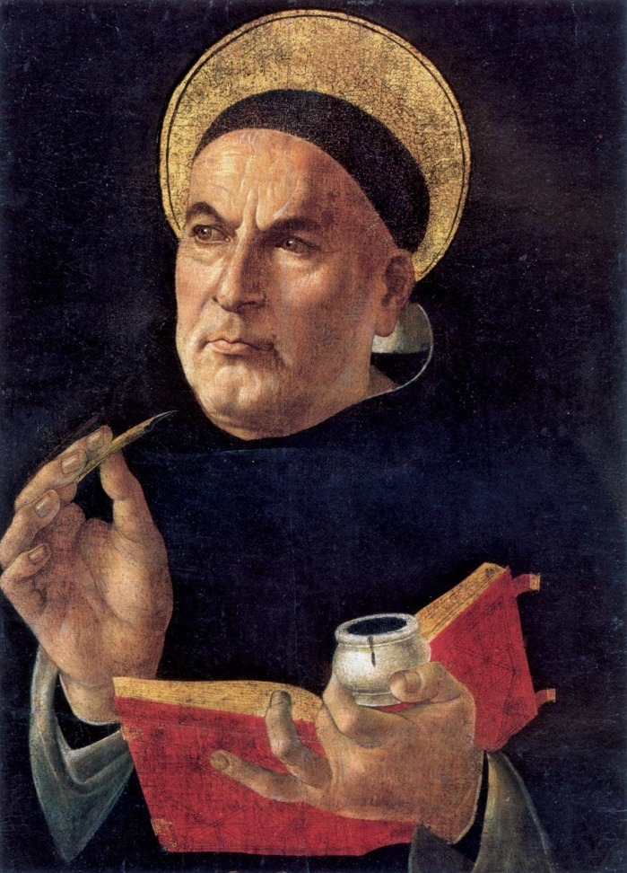

St. Aquinas’s Five Ways within Classic Theism, as Illustrated by PhilosophyPages.com and Myself:
- Argument from Motion: “There is something moving; everything that is moving is put into motion by something else. But these series of antecedent movers cannot reach back indefinitely; therefore, there must be a first mover (which is god).”
  - That which is created has an origin by which there is no force so great as to terminate its existence. The active impact of this actuality is the velocity by which the results come to form--thereby ensuring that there is to be found a potency to creation with multiple outcomes and possibilities. The sheer magnitude of power and exertion applied to a stationary object (or subject) to make it move to the point of ever-continual movement, is evidence of a pivotal catalyst. The “Unmoved Mover” is thus explained.
- Argument from Efficient Cause: “(This) begins from experience of an instance of efficient causation.”
  - Everything that is natural bears proof that the originator of the end result produced an invention so akin to the imprints of the cause, that there can be no doubt as to the prevalence of proactive impetus. For every product, there is at least one variable. The equation must naturally yield at least one substance, which shall beget another substance, until the chain of causation is finite but continuous, alluding to a “First Cause”--which/who has no antecedent.
- Argument from Necessity: “(There is a) distinction between contingent and necessary being.”
  - Every creature that exists is, as such, dependent upon a Creator for the benefit of its existence, such as a child and its mother. Without the realization that nothing comes from nothing, and that something contingent comes from another essential substance—of which a thoroughly necessary entity prevails—then one does not understand the concept of the “Irreplaceable Being”.
- Argument from Gradation: “It begins with the factual claim that we do make judgments about the relative perfection of ordinary things. But the capacity to do so, Aquinas argued, presupposes an absolute standard of perfection to which we compare everything else.”
  - In order for mere humans to assemble a basis by which to judge matters of our existence, such as the fairness of the outcome of a court trial, it must be considered that we need an absolute meter of goodness and power and knowing by which to juxtapose and measure our judgments. The force directing our compass of ethics is the “Ultimate Morality”.
- Argument from Design: “The order and arrangement of the natural world (not merely its existence) bespeaks the deliberate design of an intelligent creator.”
  - Every perceivable facet of life, whether in nature, or merely within the most fundamental laws observed behind closed doors, answers the proverbial call to the Divine. Unbeknownst to many, even the oxygen we humans breathe is an evolutionary sign that the system we are only beginning to understand works toward the end and purpose of recognizing that the “Tree Branching the Vines” feeds us through sweet photosynthesis.
Reinterpretation of The Five Ways via the Five Senses; The Sixth Way, the Sixth Sense
More prevalent a “metaphysical” reality than I have ever known is that this “God above” is not some stoic, “omnicompetent” (Atkinson, 2013) unfeeling icon of the stars who operates the universe based on some high-horse power-trip from a gold-lined podium with an iron fist and a fierce disposition toward the sinners of our world. In fact, as a blatant open theist, I argue that this divine figure is, perhaps, a mere reflection of creation’s innermost desire to realize its own full and true potential for godhood—and, is, therefore, like us, as we are like “Him.” Quite honestly, Aquinas, in my humble opinion, misses the mark when he stipulates, via direct display or not-so-subtle implication, that God is immutable (unchanging), impassible (emotionless), omnipotent (all-powerful), omniscient (all-knowing), omnibenevolent (all-loving), and eternal (existing outside of time). However, Aquinas achieves intriguing results from seemingly deep contemplation of the mystical pervasiveness of “the Highest Good”. Regardless, many of us semi-disillusioned believers would really like to think that this mysterious entity is within our often tentative grasp—as we only want to be granted knowledge of, and compassion from, Him/Her/The Great Unseen. (From now on, within the agreement toward Aquinas’s argument, “God” will be referred to as a “She” for the sake of personal convenience and preference. Later, this will be reversed--for a reason to be seen.) What a blessing that would be!
Still, Aquinas’s Five Ways to Prove God’s Existence captures some essence of the Deity that is vital for all believers (and even non-believers, if they so choose) to comprehend—especially due to the notion that each one of these five key points incorporates aspects that actually might appeal to the willing open theist / process theologian. In summary and reinterpretation of Aquinas’s words (which includes my personal addition at the bottom, the sixth one):
- God is constantly existing and moving—especially vicariously—with us (Argument from Motion).
- She caused us to come into being as a result of Her will (Argument from Efficient Cause).
- She is the independent and irreplaceable force upon which we rely (Argument from Necessary Being).
- She is the measurement and means by which we humans recognize and judge morality (Argument from Gradation).
- She is the Grand Designer (hence, the television series Designing Women) Who everlastingly (existing within time) assists Her creation in our respective purposes (Argument from Design).
- And finally (The Sixth Way) . . . She is the Master, Holy Tree, and Virgin from whence we came to ascend as Masters, ourselves (Argument from Godhood).
These are the fundamentals of my view of an open-theist philosophy, as juxtaposed with St. Aquinas’s five central concepts. Now, the question is: how to first support and then refute his position in a cohesive and comprehensive manner? Let us begin.

As to Promote the Validity of Aquinas’s Stance: The Five Ways as a Means to Access the Enigmatic Godhead through the Ascension of the Senses
The benefit of justifying Aquinas’s argument is that one can better understand his unique point-of-view and formulate a sound opinion on the matter when the audience member takes some time to absorb his multi-faceted conclusions. The primary example one can utilize to ground a position to support Aquinas’s claim would be, as I suggest, an “esoteric Christian” book, with the title The Book of Co-creation: Revelation: Our Crisis is a Birth, by well-known spiritualist and church-founder, Barbara Marx Hubbard. This fascinating document employs the last book of The Holy Bible, famous for its prevalent complexity and rich detail, and reinterprets it to advocate for humankind’s need to adopt “the Christ consciousness.” To quote, “My beloved church misunderstood me (Christ). It preached the corruptibility of humanity when I came to demonstrate its potential for incorruptibility. It propounded the sinfulness of humanity when I suffered to reveal your godliness and to overcome your guilt by demonstrating that you can totally rise above the death of the body” (Marx Hubbard). This portion of the book highlights the essential nature of realizing that, not only does God exist, it is quite possible that She desires for Her creation to know that She wishes to be recognized as our inspiration toward a higher level of existence-appreciation and overall self-worth.
One ought to be convinced by Aquinas’s plea for knowledge and reasoning for the Ultimate Entity and Her provision of connection to our ever-probing minds, which long for rationale for the metaphysical aspects of nature and the perceivably intangible. This is simply due to the notion that the basis by which Aquinas roots his argument is through a posteriori cosmology--or, put simply, post-experience and observational study of the design and order of the universe (and, in this case, application of potential understanding of the Divine via the sensory system within homeostatic concordance). Aquinas opposes St. Anselm’s ontological (“the study of existence”) argument that is founded upon a priori knowledge, which is pre-experience and stemming from the mind. All the while, thirteenth-century Saint Aquinas critiques this other method by conveying that we, as humans, are initially ignorant of the “divine essence” and cannot conceive of it without some level of experience (Philosophy Pages). Here and otherwise, Aquinas leverages Aristotelian teachings, which emphasize the observance of and direct contact with nature as it is attributed to the Grand Design of the Holy Above. Essentially, if one can see, smell, touch, taste, and hear the means by which the Earth operates upon order over chaos, prosperity over decay, and something-ness over nothing-ness, we, as a whole, are more likely to conclude that the ever-elusive “sixth sense” may actually emerge to the proverbial light, as well.

As to Negate the Validity of Aquinas’s Stance: The Five Ways as a Means to Describe a Totalitarian Deity (Now Referred to as a Male), the Godfather-head
To firmly declare, as per my fervent opposition of the harsh characterization of “the Father” via the Arguments of Motion, Efficient Cause, Necessary Being, Gradation, and Design attributed to this depiction of God, Aquinas’s suggestion that the changeable, emotional, most-powerful, most-knowing, and most-loving God (in hopeful humanity’s ascended reality) is well-formed yet is still ill-directed. Plainly to remark, one should attempt (and, pray, succeed) in transforming this series of points (as I accomplished in this paper previously in a list format) into a style of interpretation that conforms and adheres to the open-theist doctrine. This world- and God-view seems to be quite relevant in the Post-modern Age of revolutionary thought and the reinvigorating remembrance of the pivotal and intrinsic unity between God and man that ought to prevail. In truth, while I must be so inclined as to passionately qualify the Saint’s explanations, I maintain that this man’s image of God is awfully distorted, despite the cleverness of his articulations.
One of the most thorough examinations of God and atheism (disbelief in the existence of any god)--as both are put “on trial” by acclaimed court judge Vincent Bugliosi--is Divinity of Doubt. As an agnostic (one who argues that the belief in the existence of God, or lack thereof, is unknowable), this author writes, “If Christians insist on having a god, they can do so, but if they have any respect for logic, they'll have to redefine who he is” (Bugliosi). (The central reason I use quotes pertaining to Christianity is that both St. Aquinas and St. Anselm were Catholic--the name of which was once synonymous with “Christian”.) Even a person who refuses to declare himself as part of either the theist or non-theist party states that, in order to know this supernatural figure, one must adjust his/her concept of Him via a unique and individualized perception of His traits, as molding to the aspects of that for which the heart yearns. In other terms, we just need to paint our own revitalized portrait of the Actuality. If not, I believe that creation shall forever be lost in the sweeping grandeur of indifference and fear-incurring wrath that the classic-theist God possesses. Perhaps, God can be the First Mover Who moves us with easy and gradual force; He can be the Efficient Cause that catalyzes the results with a sound alchemical balance; He can be the Necessary Being upon which we humbly cling for comfort and reassurance; He can be the Degree of Morality by which we judge our self-worth as His mutually loving children; and He can be the Grand Designer Who structures the universe as if it were a masterpiece before our very eyes, as a gift for us alone.
However, we remain at somewhat of an impasse--a frequently mind-boggling complexity at which even some philosophers decide to forgo the problem entirely and select skepticism (constant questioning to the point of doubt) as the path for them, convinced that one need not discuss or debate the existence of God, at all--as in Scotsman David Hume’s stance. Then, of course, Bugliosi later assumes the position that to wade in mysterious waters is a metaphor for the probability that this “God question” will never be solved.

Justification for the Open-theist View of this Methodology: Modification of The Five Ways
In order to substantiate the claim I am making that it is best for the open-minded theist to hold an open-/process-theist position, I have decided to utilize Stanford University's philosophy Web site to demonstrate my personal clarification of the ways in which Aquinas’s message to the senses should be perceived:
Process theism's doctrine of creativity differs from that of classical theism according to which God alone is genuinely creative. Thomas Aquinas says that in the proper sense of the word, only God creates (Summa Theologica I, Q 45, a. 5). Aquinas explains that to create is to bring something from nothing, and this is possible only for deity. This is the famous doctrine of creatio ex nihilo, or creation from no pre-existing material. This ex nihilo creation is logically distinct from the claim that the universe is temporally finite. Aquinas, for example, treats the questions whether God is the creator and whether the universe had a beginning under separate headings. Aquinas is clear that he accepts the temporal finitude of the universe as a matter of faith, from revelation, and not because of rational argument. On the other hand, like other traditional theists (Gottfried Leibniz for example), Aquinas holds that God could have created a temporally infinite universe, but it too would have been created ex nihilo.
In this fascinating manner of description, Thomas Aquinas is portrayed as holding to the doctrine that, in order to be made manifest, all creation needed to have sprung from the Efficient Causality, in which a Supreme Being turned nothing-ness into something-ness. While one may agree that this was possible, it is not likely, in my view, that an unfeeling and unmovable God would feel the sheer emotion of inspiration so as to create the three souls: nutritive (plants), sensitive (animals), and rational (humans) (Aristotle). While God, in classic theism, may embody love as a whole, how can S/He not exist as the all-loving Being without feeling love to begin with? How would we ground our judgments if not through a mental, social, emotional, and even physical connection to the divine that is made reciprocal through an emotional presence Who lives vicariously through us and is everlasting (existing within time). In order for God to have moved us, caused us, necessitated us, degreed/graded us, and designed us, S/He would have had, imperatively, to be made in our image just as much as the reverse. For, without this, we would certainly have little to no concept of the Godhead, and, thus, surely, would falter in the murky waters of doubt and indifference.

Works Cited
Aristotle. "Aristotle on the Soul." Washington.edu. S. Marc Cohen, 10 Dec 2004. Web. 28 Mar 2013. <http://faculty.washington.edu/smcohen/320/psyche.htm>.
Atkinson, Shannon. "Classic Theism, the ‘Omni-s,’ and St. Aquinas's Five Ways." Philosophy of Religion Lecture. Salt Lake Community College. Taylorsville-Redwood, Salt Lake City. 05 Mar 2013. Lecture.
Bugliosi, Vincent. Divinity of Doubt: God and Atheism on Trial. New York: Vanguard Press, 2011. Print. <http://www.goodreads.com/book/show/9650144-divinity-of-doubt>.
Kemerling, Garth. "Bonaventure and Aquinas; Five Ways to Prove God's Existence." Philosophy Pages. N.p., 12 Nov 2011. Web. 28 Mar 2013. <http://www.philosophypages.com/hy/3n.htm>
Marx Hubbard, Barbara. The Book of Co-creation: Revelation: Our Crisis is a Birth. 2nd. ed. New York, NY: Nataraj Publishing , 1993. Print. <http://www.goodreads.com/book/show/1668974.The_Revelation>.
Viney, Donald, "Process Theism", The Stanford Encyclopedia of Philosophy (Winter 2008 Edition), Edward N. Zalta (ed.), <http://plato.stanford.edu/archives/win2008/entries/process-theism/>.

